|  |  |
| --- | --- |
| CURSO DE CYBER-SECURITY  **EXERCÍCIOS DE APLICAÇÃO – VLANS – VTP PROTOCOL** |  |
|  |  |

**EXERCÍCIOS DE APLICAÇÃO – VTP PROTOCOL**



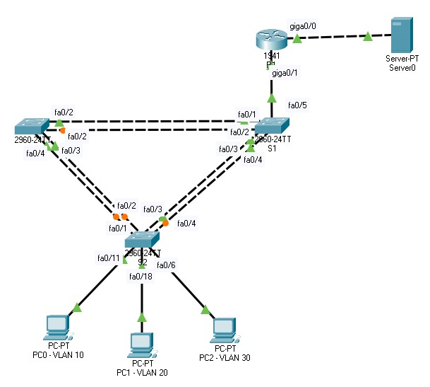

1. Constroi um cenário idêntico ao do diagrama acima.
2. Desative todas as portas dos switches.

1. Efetue as seguintes configurações básicas:
   1. Hostname R1, S1, S2 e S3;
   2. Desativar o DNS Lookup;
   3. Configure a password do enable secret (Class)
   4. Configurar o acesso consola com a password cisco;

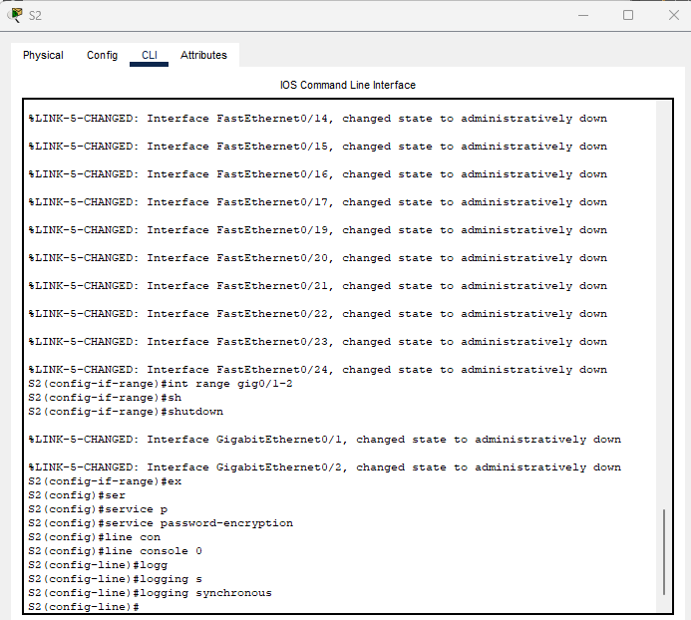

1. Configure o protocolo VTP em todos os switches:
   1. S1 será o VTP server e o S2 e S3 o VTP clients;
   2. Dominio VTP será lab5;
   3. A password VTP será cisco;

1. Crie as seguintes VLANs no VTP server:

|  |  |  |
| --- | --- | --- |
| **Portas** | **Vlan** | **Network** |
| Fa0/5-10 | Vlan 30 – Guest | 172.17.30.0/24 |
| Fa0/11-17 | Vlan 10 – Staff | 172.17.10.0/24 |
| Fa0/18-24 | Vlan 20 - Students | 172.17.20.0/24 |

1. Configure todas as portas nos modos de acesso ou trunk consoante o diagrama e adiciona-as às respetivas VLANs.   
   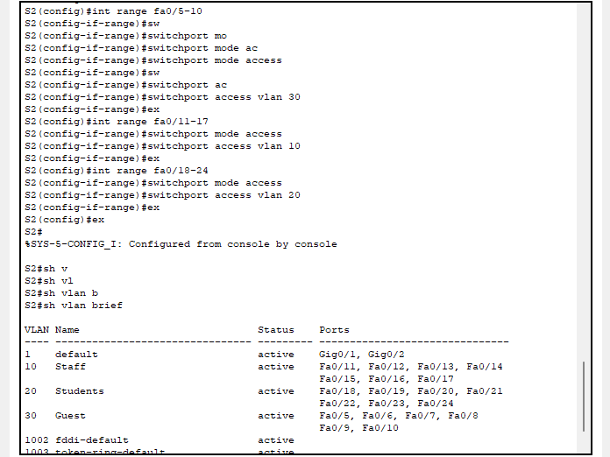  
   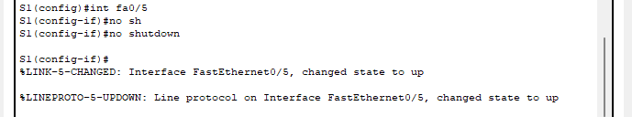  
   A white background with black text

   Description automatically generated  
   A white background with black text

   Description automatically generated
2. Crie e configure todas as sub-interfaces necessárias no router e faça o encapsulamento de cada uma delas às suas VLANs. Utiliza o primeiro endereço de ip disponível na rede para cada uma das sub-interfaces.

sh running-config

1. Configure a interface da LAN do servidor e atribui o último endereço da rede ao servidor (Usa a rede 172.17.50.0/24)   
   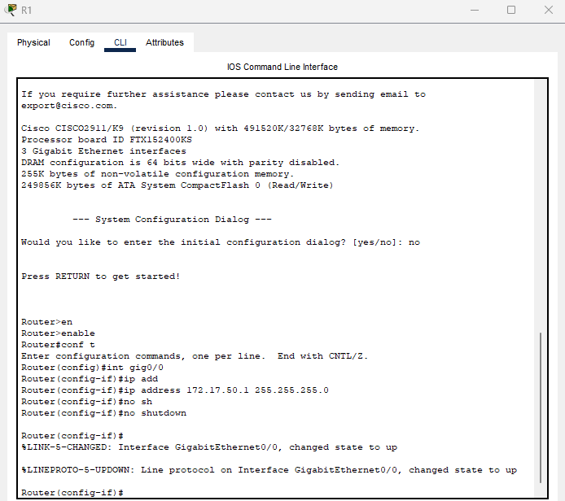  
   A screenshot of a computer

   Description automatically generated
2. Configure o serviço DNS com o dominio lab5.pt e ative o serviço HTTP.   
   A screenshot of a computer

   Description automatically generated  
   A screenshot of a computer

   Description automatically generated

CURSO DE

CYBER

-

S

E

CURITY

**EXERCÍ**

**CIOS DE APLICAÇÃO**

**–**

**VLANS**

**–**

**V**

**TP**

**PROTOCOL**



1. Configure o serviço DHCP no router para uma das VLANs. O DNS server deverá ser o servidor web.

1. Teste o ping entre os terminais de cada uma das VLANs.

